Name: Dara Sen
Class: AD361

Lab – Week 6

Step 1: Exploratory Testing
- Testing Charter: I investigated how the Increment, Decrement, and Reset buttons work and affect the displayed count.
Action | Expected Result | Actual Result | Pass or Fail
Click “Increment” | Change from 0 to 1 | Count: 1 | Passed
Click “Decrement” | Change from 0 to -1 | Count: -1 | Passed
Click “Reset” | Change any count value to 0 | Count: 0 | Passed
Click “Increment” two times | Change from 0 to 2 | Count: 2 | Passed
Click “Increment” and then click “Decrement” | Change from 0 to 1 and then 1 back to 0 | Count: 0 | Passed
(Note: I refreshed the page for each execution)

Step 2: Examine the Source Code
Based on the examination, there is no branch or loop coverage for this file. The component started the ‘count’ by initializing at 0. Once each button was triggered, the function updated the state to increment or decrement by 1 or to reset to 0.
Step 3: Create the Test File
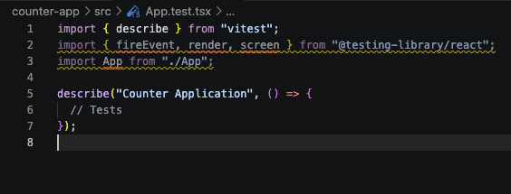
‘App.test.tsx’ was created.

Step 4: Test the Starting State
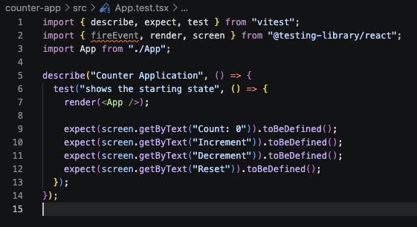

Step 5: Test Statement Coverage
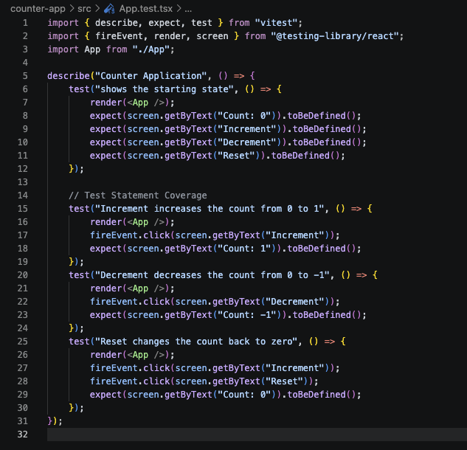
Step 6: Test a Sequence of Actions
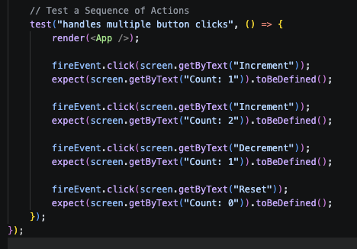

Step 7: Run the Tests
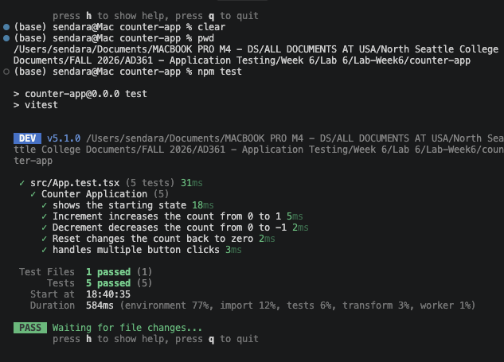

Step 8: Review Code Coverage
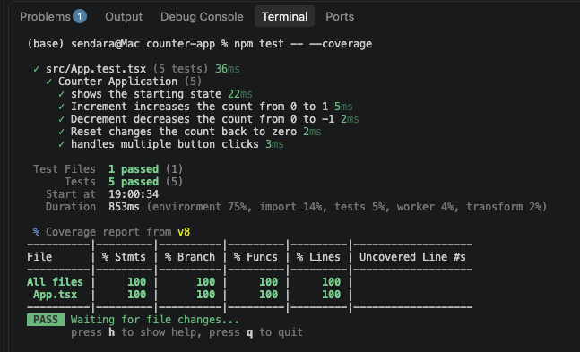
Coverage Type | Percentage
Statements | 100%
Branches | 100%
Functions | 100%
Lines | 100%

I tested all statements in the file and the component did not have branches or loops so the branch coverage was not significant.

Step 9: Compare the Two Approaches
For exploratory testing, it helped me discover how buttons behaved from my interaction, like clicking each button. The white-box testing further helped me review the source code to ensure the logic is correct.

